Member:

MemberID ,Auto increment=INT as varchar is not necessary for the id,int being sufficient,auto increment is used to automatically allocate ids based on order of entry.

Email,UNIQUE=so no two users can use the same email can cause confusion in the database and flow of work in the distribution process

Password 200 varchar so the user can set a good strong password

Phonenumber,varchar=because users tend to add a plus or a 0 at the beginning of their number,causes less confusion

MemberType CHECK ('Seller','Buyer')=so the only acceptable entries in the column are buyer or seller,the only two options available to users.

DateJoined (DATE,DEFAULT CURRENT_DATE)=The date the user join is default automatically to the creation of the user.

TotalSalesAmount/DEFAULT 0= De-normalization with the purpose of making the querry of finding what who sold how ,uch easier without includind joins and making the analysys process more easy.Default 0 as there are two types of users,buyers and sellers,the latter not being able to add to the sales amount as the buyers add to the sales amount,0 default being the best solution for not creating confusion in the database.

TotalOrders/DEFAULT 0= De-normalization with the purpose of making the querry of finding out how many orders a user has made throughout time easier and less slow.at the cost of redundancy the database is more efficient.Default 0 as it makes sense to assume that member has not made any order yet then any at all.

Electronic Item:

ItemID Auto increment= INT as varchar is not necessary for the id,int being sufficient,auto increment is used to automatically allocate ids based on order of entry.

VARCHAR(color,brand,model,condition) where set to the appropriate amount as not to have the database as efficient as possible.

Condition Check/Default= New,Used,Poor as these are the three levels of quality of the products.set the default to used as it would be appropriate for a second hand shop,not to create confusion and unhappiness from customers for buyng false advertised products.

Item_Type/CHECK= CHECK for gadget and accessory as they are the only two item types viable for the database,it makes data insertion better and more straightforrward

Price=decimal (6,2) as having a bigger amount would be illogical as no product would even come close to the maximum amount

Stock_Count DEFAULT 0=default to 0 as it is better to default to 0 as not to create confusion relating the availability of the item.

Total_Quantity_Sold/DEFAULT 0=used de-normaliztion in order to querry for total sales more efficiently,without having to join Electronics table with the .default 0 because it is better to assume that we did not sell anything then we did so as to not create confusion in the database.

DateOfPurchase/DEFAULT 0=Default to current date as it would make data insertion easier and more effeicient

Orders:

OrderID Auto Increment= INT as varchar is not necessary for the id,int being sufficient,auto increment is used to automatically allocate ids based on order of entry.

OrderDate Default CURRENT_DATE=default current date as to assume that data insertion would be made in the same day as the order being put

OrdersInfo:

Quantity/DEFAULT= Default to 1 as it is to assume that an order would have logically at least one item,not 0.Helps to stop confusion and better data insertion.

Gadgets VIEW:

View made in order to better asses the gadgets in the electronic_items table

Accessories VIEW:

View made in order to better asses the accesories in the electronic_items table

SALES TABLE:

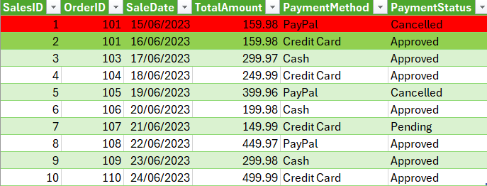

Sales table is important as it tracks sales,successful payments,can find out suspicious payments by number of cancelled payments,can study the trend of payment methods and keep a record of cancelled pending and approved payments for future reference.

As per image,two separate salesids are made on one single order as one time the bank or customer cancelled the payment and so they needed to try another time with another payment method.this way we can record if we have any issues regarding specific payment methods (they do not work,so we can troubleshoot easly)or if some customer is engaging in fraudulent behaviour having several cancelled payments in a row.or to have in house proof of history of purchase for customers. (image bellow).

